**Group 3’s Project 2 Proposal:**

**Topic**: Sleep in the USA

**Data set**: <https://chronicdata.cdc.gov/500-Cities/500-Cities-Sleeping-less-than-7-hours-among-adults/eqbn-8mpz>

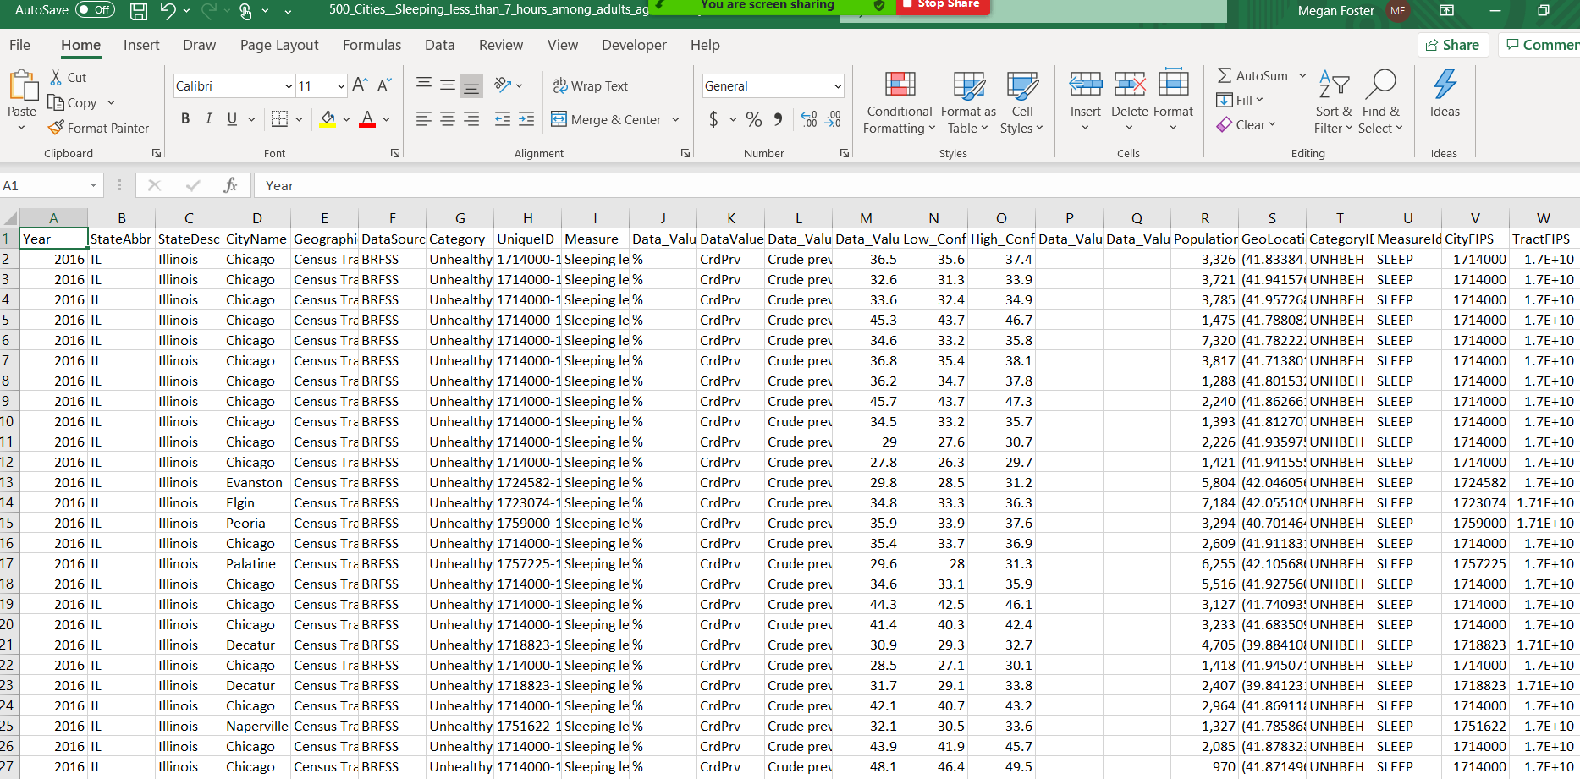

**Project Summary**: We want to look at possible correlating/causation factors influencing sleep (or lack thereof) and any patterns visible across states. We are particularly interested in comparing sleeping less than 7 hours a night and the prevalence of other poor health factors such as obesity or high blood pressure. Beyond this, we also want to see if factors such as median income, TV watching habits, or even the weather may correlate with less sleep per night.

**Visualization Vision**: Map of USA at the Top of Page where you can click a state to update visualizations on the dashboard

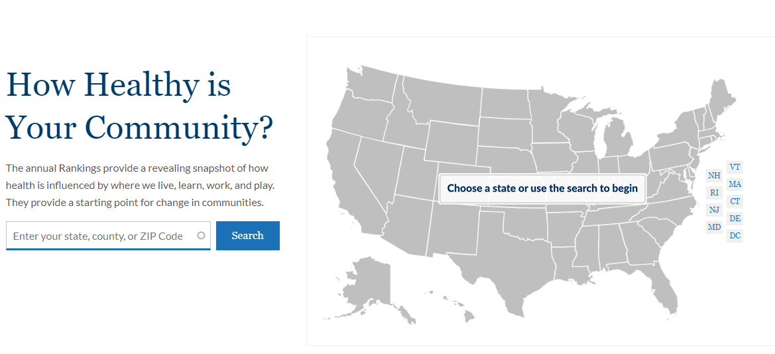

**Visualization Ideas:**

Bar Chart by State: Compare Sleep Under 7 Hours in Adults against a variety of other health components (i.e. obesity, high blood pressure, arthritis, etc.)

US Comparison D3 chart by state of average sleep under 7 hours and median income (state selected is highlighted)

If time allows ourTBD Visual ideas would show an additional comparison against:

* Weather (average temperature)
* Heart Health
* Television Viewing by the hour (also broadcasting on East Coast often much later leading to later bedtimes)
* State Population

**Other Potential Resources**:

* <https://sleepdata.org/datasets>
* <https://www.quora.com/Do-people-on-the-U-S-east-coast-stay-up-later-than-people-on-the-U-S-west-coast>

Visualization Heat Map:

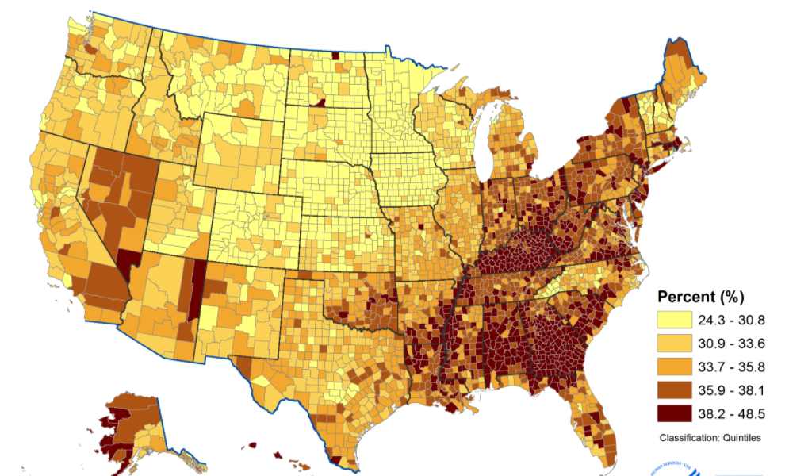

Github link: <https://github.com/meganfoster/Group_3_Project_2>